Bluetooth Controlled Home Automation System Using Arduino – Tinkercad Report

Title
Design and Implementation of Bluetooth Controlled Home Automation System Using Arduino in Tinkercad

Aim
To design and simulate a Bluetooth-controlled home automation system using Arduino in Tinkercad for controlling electrical devices ON and OFF wirelessly.

Objective
- To understand Bluetooth communication using Arduino.
- To control home appliances remotely using a mobile phone.
- To simulate the circuit in Tinkercad.
- To learn serial communication between Bluetooth module and Arduino.

Components Required
S.No | Component Name | Quantity
1 | Arduino UNO | 1
2 | HC-05 Bluetooth Module | 1
3 | Relay Module | 2
4 | Bulbs/LEDs | 2
5 | Resistors (220Ω) | 2
6 | Breadboard | 1
7 | Jumper Wires | As required
8 | Smartphone with Bluetooth Terminal App | 1

Software Used
- Tinkercad Circuits Tinkercad
- Arduino IDE

Theory
Home automation is a modern technology used to control household electrical appliances automatically or remotely. In this project, Bluetooth technology is used for wireless communication between a smartphone and Arduino UNO.
The HC-05 Bluetooth module receives commands from the mobile phone and sends them to the Arduino through serial communication. Depending on the command received, Arduino switches the connected devices ON or OFF using relay modules.
This system is low-cost, simple, and useful for smart home applications.

Circuit Connections

HC-05 Bluetooth Module to Arduino
HC-05 Pin | Arduino Pin
VCC | 5V
GND | GND
TXD | RX (Pin 0)
RXD | TX (Pin 1)

Relay Connections
Relay Pin | Arduino Pin
IN1 | Pin 7
IN2 | Pin 8
VCC | 5V
GND | GND

Load Connections
- Bulb/LED 1 connected through Relay 1
- Bulb/LED 2 connected through Relay 2

Working Principle
- The smartphone sends Bluetooth commands using a Bluetooth terminal application.
- The HC-05 module receives the commands.
- Arduino reads the received data through serial communication.
- According to the command:
  - Device 1 turns ON/OFF
  - Device 2 turns ON/OFF
- Relay modules act as switches for controlling appliances.

Example Commands
Command | Action
A | Device 1 ON
a | Device 1 OFF
B | Device 2 ON
b | Device 2 OFF

Arduino Program
char data;

void setup()
{
pinMode(7, OUTPUT);
pinMode(8, OUTPUT);

digitalWrite(7, LOW);
digitalWrite(8, LOW);

Serial.begin(9600);
}

void loop()
{
if (Serial.available() > 0)
{
data = Serial.read();

if (data == 'A')
{
digitalWrite(7, HIGH);
}

else if (data == 'a')
{
digitalWrite(7, LOW);
}

else if (data == 'B')
{
digitalWrite(8, HIGH);
}

else if (data == 'b')
{
digitalWrite(8, LOW);
}
}
}
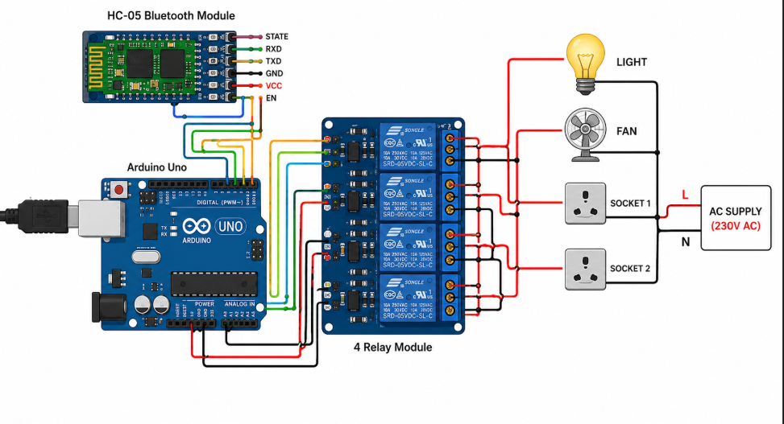

Procedure
- Open Tinkercad and create a new circuit.
- Place Arduino UNO, HC-05 module, relays, and LEDs.
- Connect all components according to the circuit diagram.
- Upload the Arduino code.
- Start simulation.
- Connect mobile Bluetooth to HC-05.
- Send commands using Bluetooth terminal app.
- Observe devices switching ON and OFF.

Advantages
- Wireless control of appliances
- Low cost and simple design
- Easy to operate
- Energy saving
- Useful for smart homes

Applications
- Smart home systems
- Industrial automation
- Wireless lighting control
- Security systems
- Remote appliance control

Result
The Bluetooth-controlled home automation system was successfully designed and simulated in Tinkercad. The appliances were controlled wirelessly using Bluetooth commands from a smartphone.

